**ODCM – Team project – Team 3 – Scraping the Dutch Housing Market – huizenzoeker.nl**

The navigation path is defined by how an user would navigate the site in a web browser, and needs to be specified both with an entity (obtaining data on all instances of an entity) and across multiple entities (navigating from one instance of an entity to one or multiple instances of a related entity). For each single entity you extract data for, you need to extract data from multiple pages; e.g. by slightly modifying the instance’s URL or via interaction (clicking, scrolling). Next, user behaviour is simulated to view how the content is dynamically loading.

Our navigation path can be divided into several steps or ‘pages’ the user would visit to go from the general huizenzoeker.nl/woningmarkt/ page, to the huizenzoeker.nl/woningmarkt/*province* page, to go to the huizenzoeker.nl/woningmarkt/*province*/*municipality* page.

**Step 1: Arriving at** [**https://www.huizenzoeker.nl/**](https://www.huizenzoeker.nl/)

First users arrive at the home page of the huizenzoeker site.

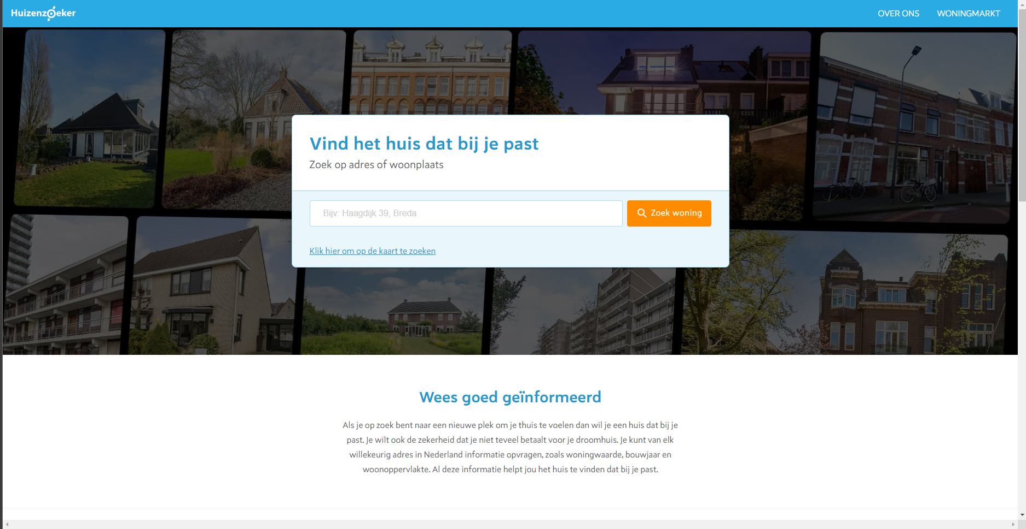

They then need to scroll down, where they will find in the bottom-right corner the ‘Woningmarkt’ section, which leads them to the Woningmarkt page for each respective province they decide to click on, which contains information on the current situation of the housing market in that province.

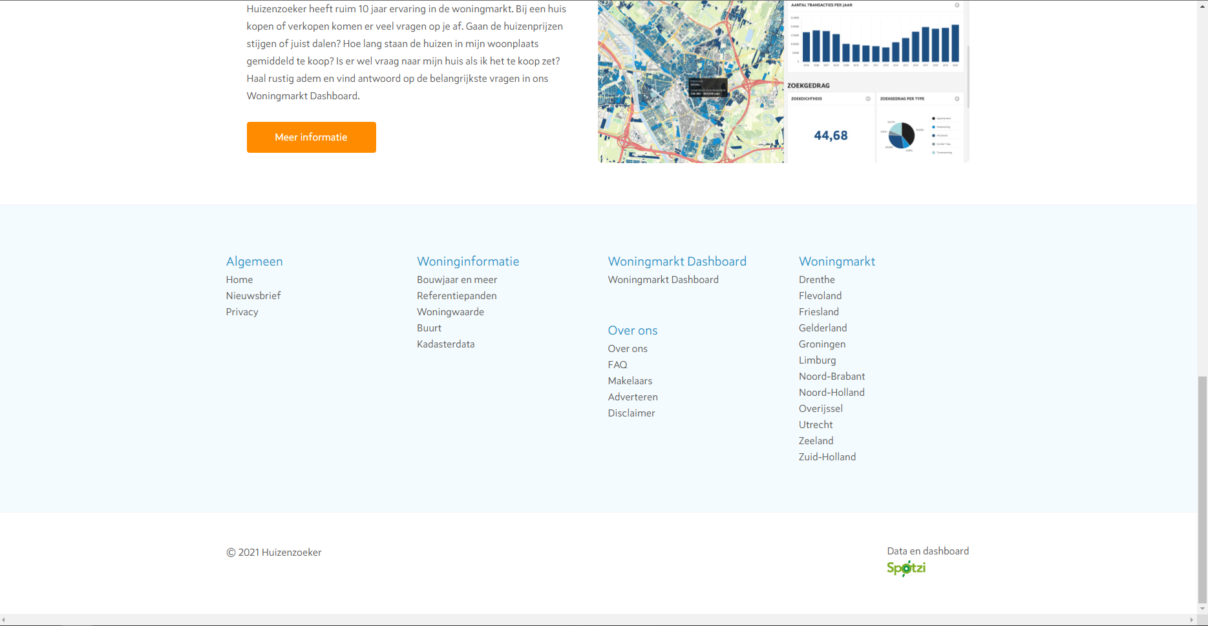

We will for now assume that the user clicks on the province ‘Noord-Brabant’.

**Step 2: Arriving at** [**https://www.huizenzoeker.nl/woningmarkt/noord-brabant/**](https://www.huizenzoeker.nl/woningmarkt/noord-brabant/)

The user has now arrived at the woningmarkt page for the province Noord-Brabant. Here the user can find a lot of information about the current housing market situation in the province, for the previous month and how these figures have increased/decreased compared to the month before.

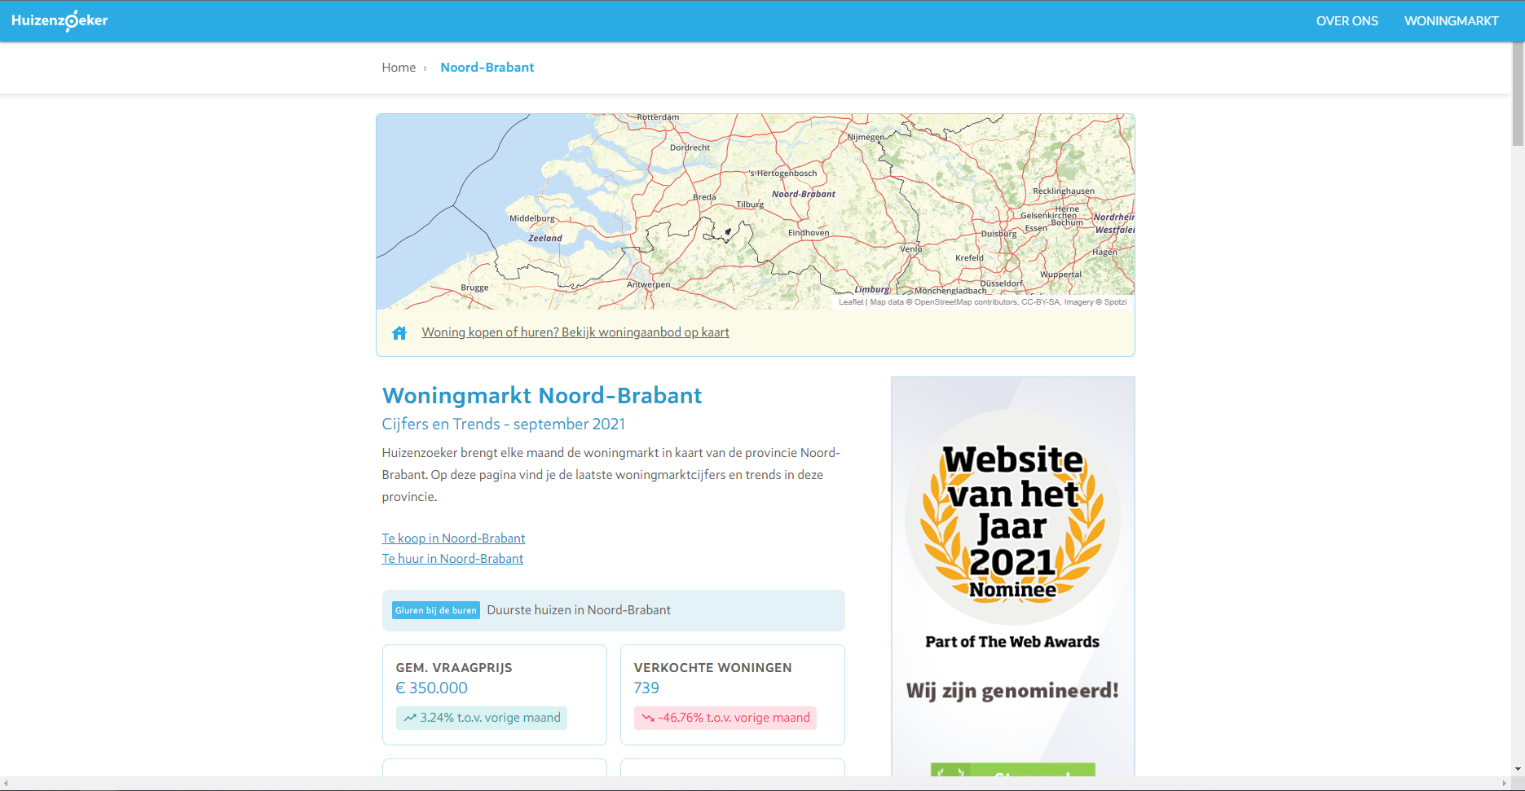

Firstly, the user will come across the trend data for the province, including the gemiddelde vraagprijs, the number of verkochte woningen, the average vierkantemeter prijs, and the percentage overboden. For each of these figures the user can see how these numbers have changed over the month before.

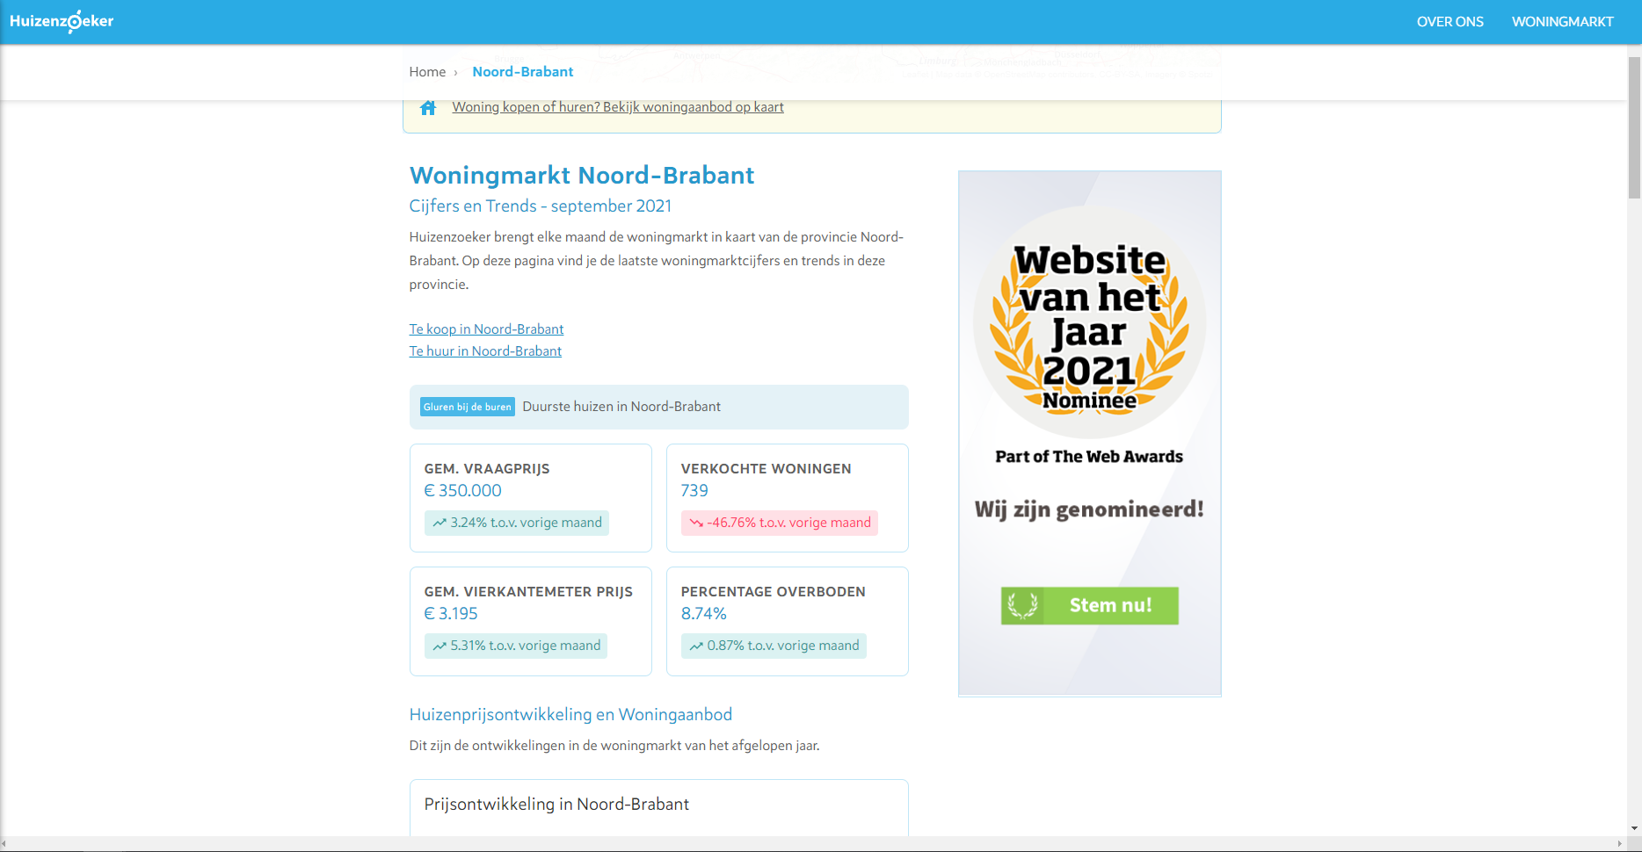

Secondly, the user sees some graphs displaying the developments in housing prices over the last year, per month, for this province.

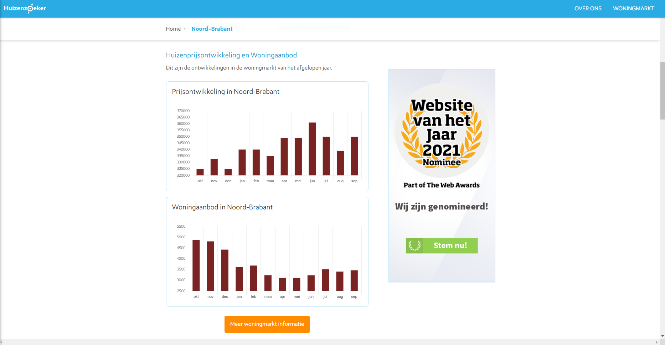

Thirdly, there Is some text that more elaborately explains the housing market and demographics of the province, and also a pie-chart with the age distribution in the province:

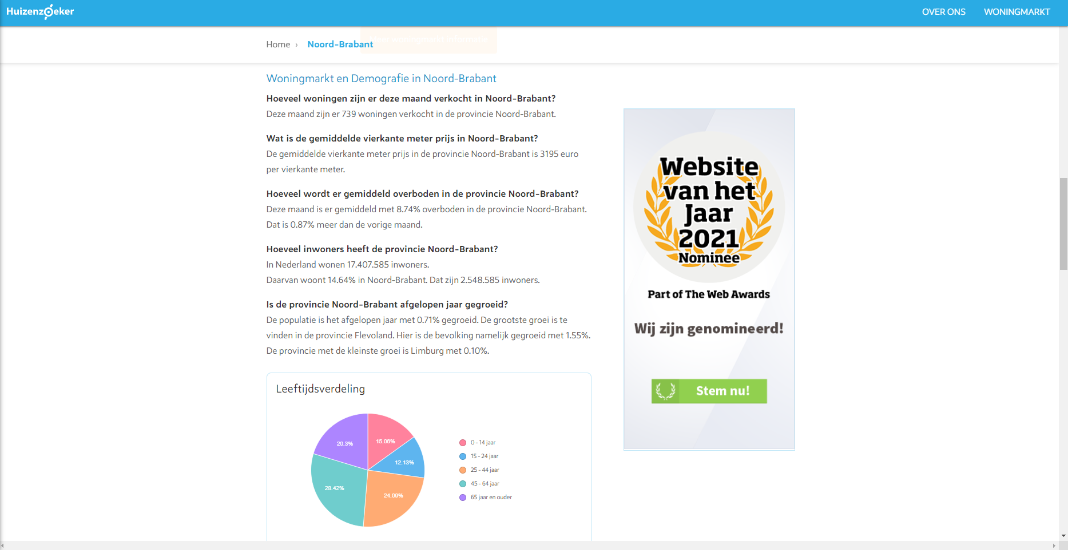

Then we see the average disposable income per household in the province and some houses that are currently available on the market.

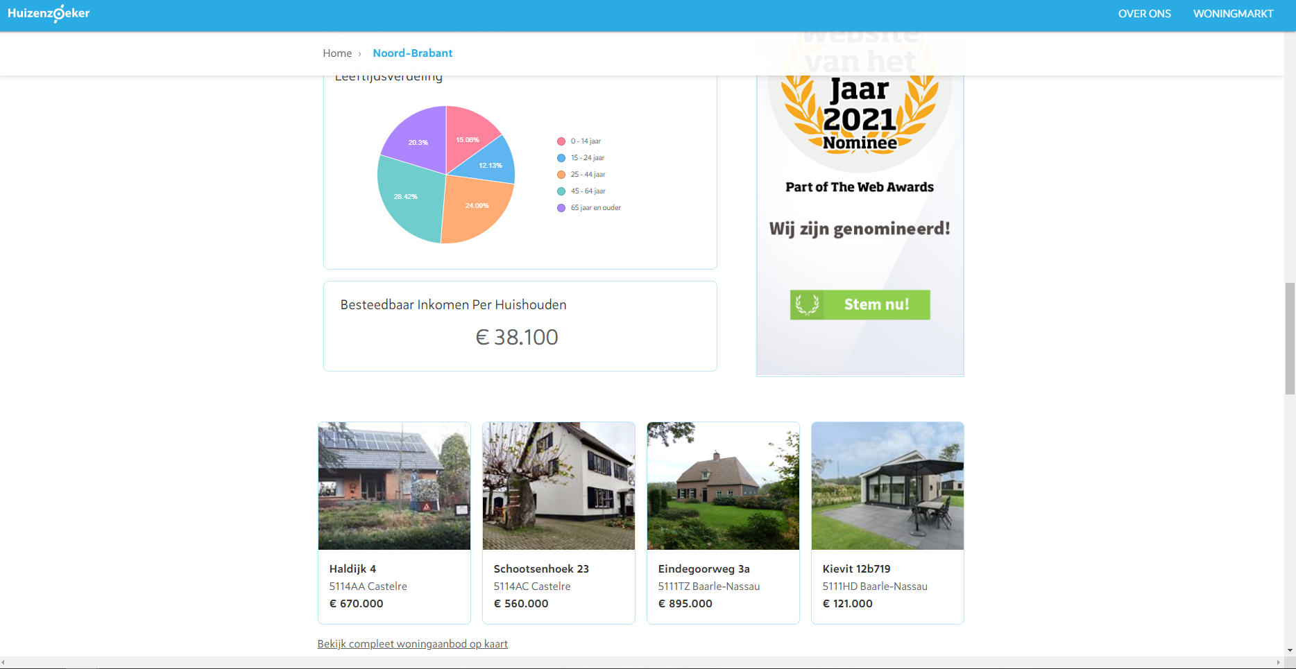

Then finally at the bottom of the page, we see an overview of the different municipalities of the province, which links us to the figures on the Woningmarkt page for each municipality individually:

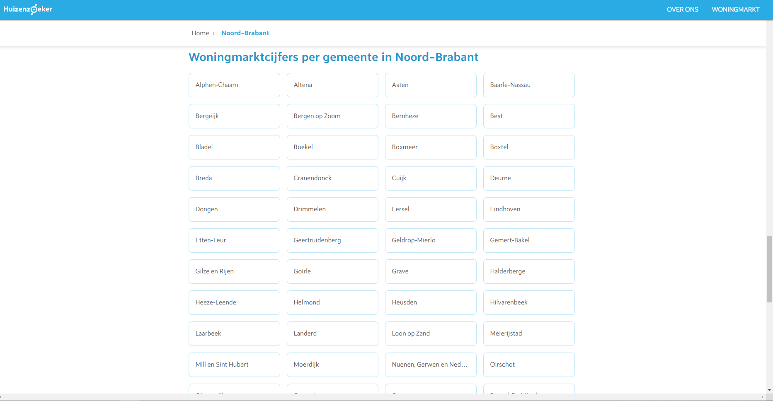

For now we assume that the user will go the municipality ‘Tilburg’.

**Step 3: Arriving at the** [**https://www.huizenzoeker.nl/woningmarkt/noord-brabant/tilburg/**](https://www.huizenzoeker.nl/woningmarkt/noord-brabant/tilburg/)

The user has now arrived at the woningmarkt page for the municipality Tilburg in the province Noord-Brabant. Here the user can find more specific information on the current housing market in the municipality Tilburg for the last month, and how these figures again have increased/decreases compared to the month before.

Similarly to the province woningmarkt pages, the municipality woningmarkt page shows similar figures:

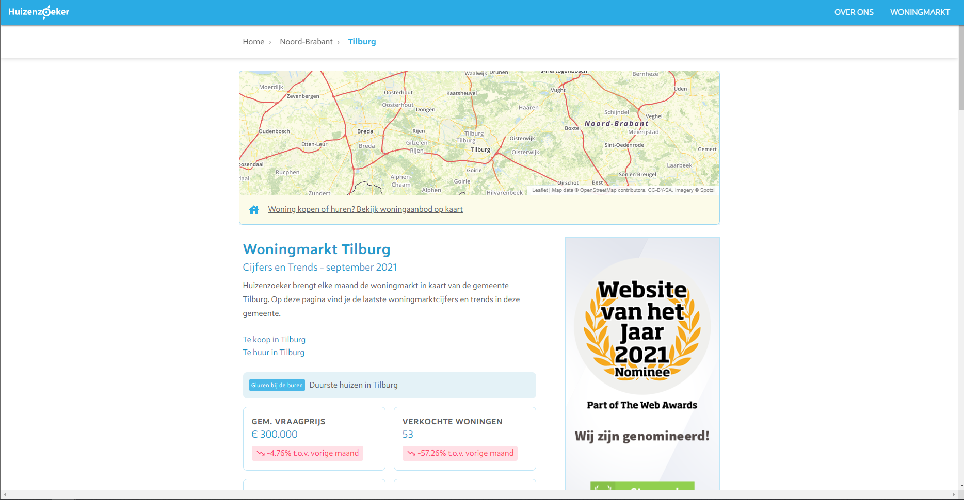

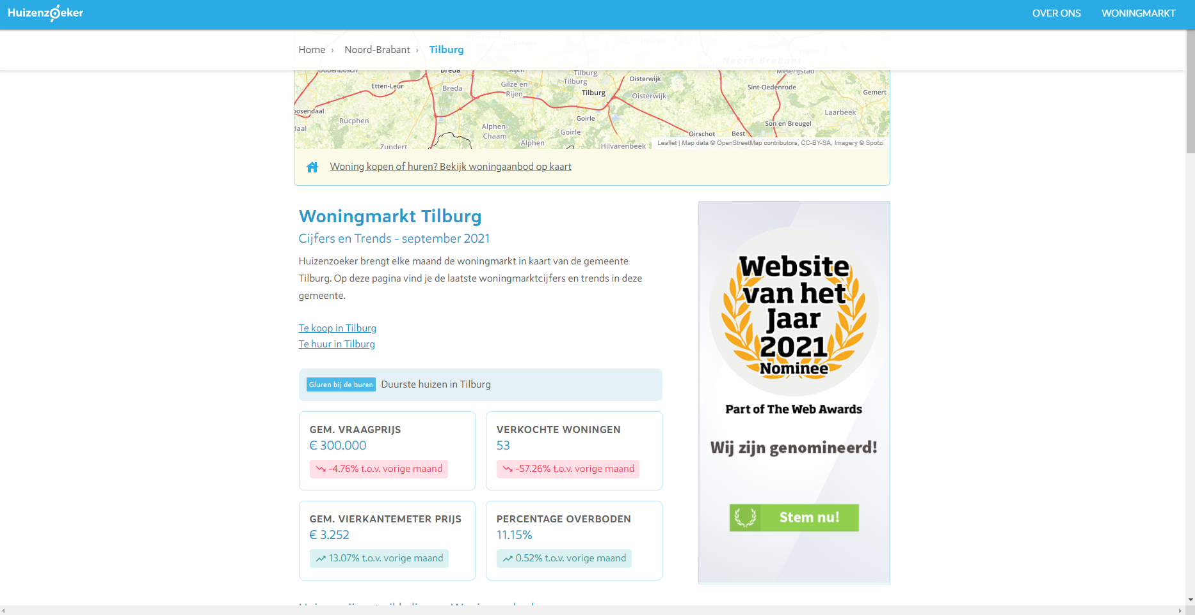

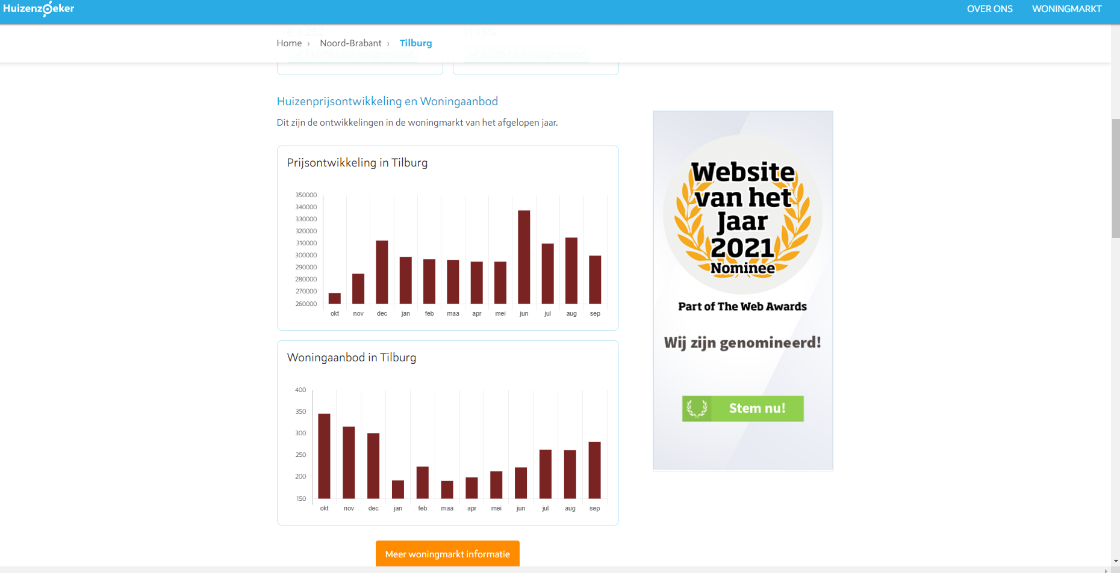

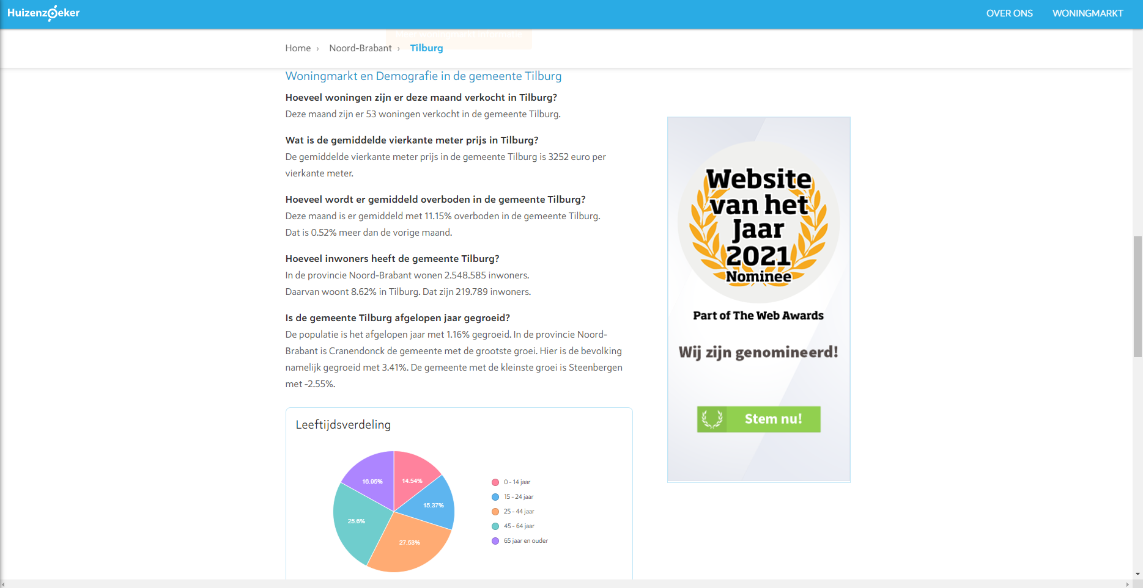

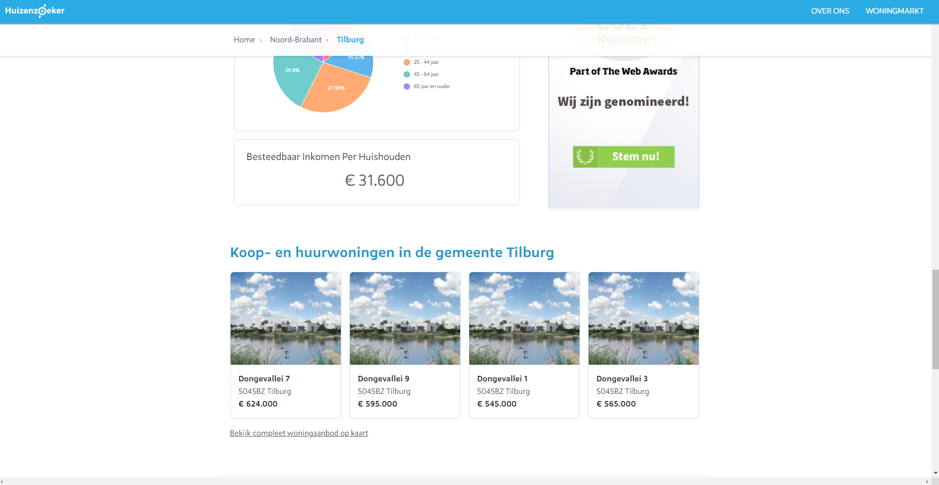

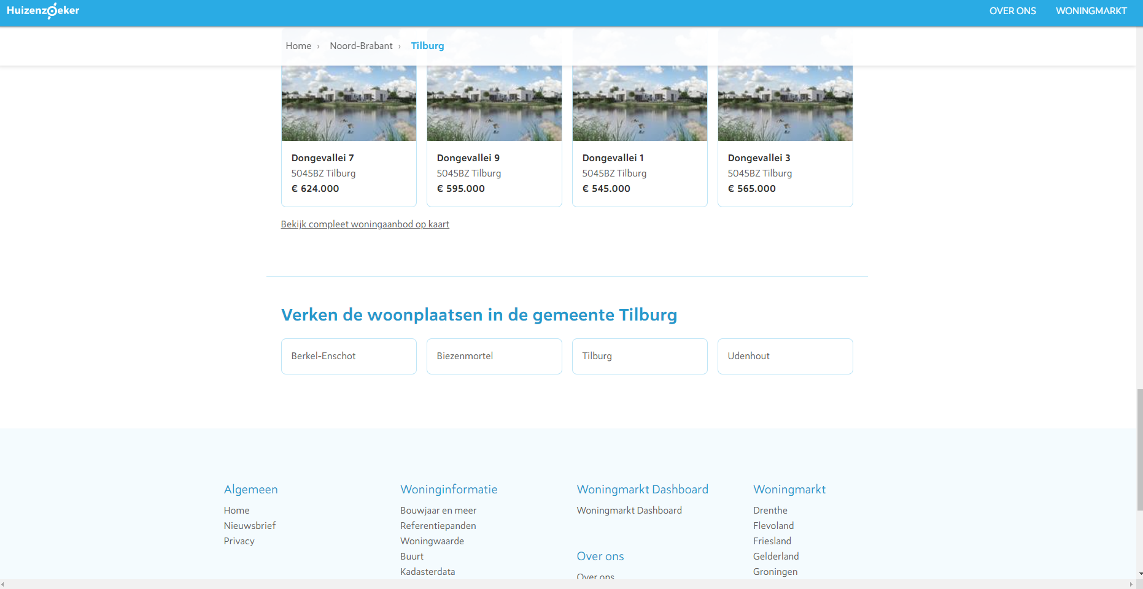

Then at the bottom of the page under ‘Verken de woonplaatsen in gemeente *’, the site lists the different residences per municipality. If the user would then click on ‘Berkel-Enschot’ for instance, and again scrolls down to the bottom of the page, a list will appear with all street names in Berkel-Enschot, and once clicked will lead the user to very specific information on a particular street, in a particular residence, in a particular municipality, in a particular province!

However, since the dataset would grow too large if we would include áll this data, we decided to focus our scraping efforts on the province- and municipality-level information.

A visual summary of our navigation path:

*If you try to type the ‘www.huizenzoeker.nl/woningmarkt/’ URL directly into the search bar it redirects you do the home page of Huizenzoeker.nl; there is thus no main page for the woningmarkt part of the site specifically.